MyMainScript 1
MeanShiftSegmentation 1
Your code here 1

MyMainScript
tic;

MeanShiftSegmentation
We perform the mean-shift-segmentation using both the color(RGB) and the
spatial-coordinate(XY) features. Firstly we apply a gaussian filter on the
image and subsample it with a factor of 0.5 so that our algorithm dosen't
take too long because of the large size of the image. We took exponential
kernel function for the segmentation algorithm. To handle both the color
and spatial coordinate features together, we converted our 3-D (RGB) image
to a 5-D(RGBXY) image with the features scaled by their respective
gaussian kernel bandwidth feature parameters (hr and hs). For using knn
search for finding the neighbours and to use the algorithm efficiently,
we flattened the HxWx5 image as HxW,5 vector. After sufficient number of
iterations of the mean shift, we output the 3-D (RGB) segmented image.
Abbreviations
Gaussian kernel bandwidth for the spatial feature - hr
Gaussian kernel bandwidth for the color feature - hs
Nuber of iterations - iterations
Number of segments - nos
For baboonColor image - hr=1, hs=50, iterations=20, nos=10
For flower image - hr=1, hs=100, iterations=20, nos=9
For bird image - hr=1, hs=30, iterations=20, nos=6

Your code here
myNumOfColors = 200;
myColorScale = [ [0:1/(myNumOfColors-1):1]' , [0:1/(myNumOfColors-1):1]' , [0:1/(myNumOfColors-1):1]' ];
%%%%%%%%%%%%%%%%%%%%%%%%%%%%%%%%%%%%%%%%%%%%%%%%%%%%%%%%%%%%%%%%%%%%%%%%%%%%%%%%%%%%%%%%%%%%%%%%%%%%%%%%%%%%%%%%%
img=imread('../data/baboonColor.png');
f = figure();
imagesc (img), title("Original Image");
saveas(f, strcat('../images/', 'baboonColor_original.png'));
out=myMeanShiftSegmentation(img, 1, 50, 150, 20, 0.5);
f = figure();
imagesc(out), title(['Segmented Image hr=1' ' hs=50' ' iterations=20']);
saveas(f, strcat('../images/', 'baboonColor_segmented.png'));
%%%%%%%%%%%%%%%%%%%%%%%%%%%%%%%%%%%%%%%%%%%%%%%%%%%%%%%%%%%%%%%%%%%%%%%%%%%%%%%%%%%%%%%%%%%%%%%%%%%%%%%%%%%%%%%%%
img=imread('../data/flower.jpg');
f = figure();
imagesc (img), title("Original Image");
saveas(f, strcat('../images/','flower_original.png'));
out=myMeanShiftSegmentation(img, 1, 100, 150, 20, 0.5);
f = figure();
imagesc(out), title(['Segmented Image hr=1' ' hs=100' ' iterations=20']);
saveas(f, strcat('../images/','flower_segmented.png'));
%%%%%%%%%%%%%%%%%%%%%%%%%%%%%%%%%%%%%%%%%%%%%%%%%%%%%%%%%%%%%%%%%%%%%%%%%%%%%%%%%%%%%%%%%%%%%%%%%%%%%%%%%%%%%%%%%%
img=imread('../data/bird.jpg');
f = figure();
imagesc (img), title("Original Image");
saveas(f, strcat('../images/','bird_original.png'));
out=myMeanShiftSegmentation(img, 1, 30, 150, 20, 0.5);
f = figure();
imagesc(out), title(['Segmented Image hr=1' ' hs=30' ' iterations=20']);
saveas(f, strcat('../images/','bird_segmented.png'));
%%%%%%%%%%%%%%%%%%%%%%%%%%%%%%%%%%%%%%%%%%%%%%%%%%%%%%%%%%%%%%%%%%%%%%%%%%%%%%%%%%%%%%%%%%%%%%%%%%%%%%%%%%%%%%%%%
toc;
Elapsed time is 176.209983 seconds.
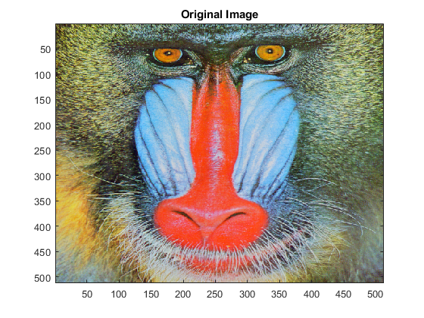
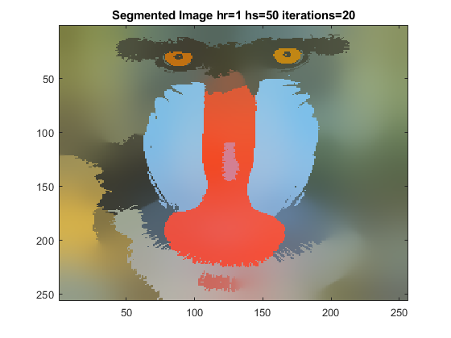
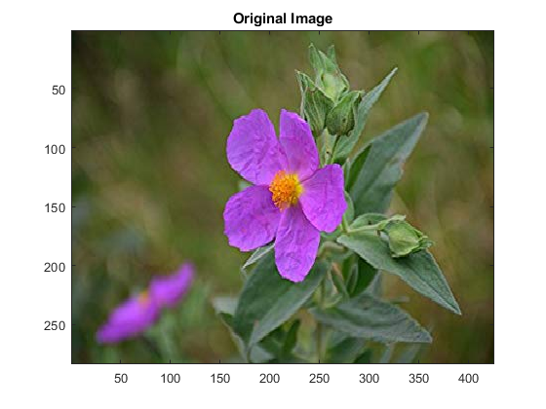
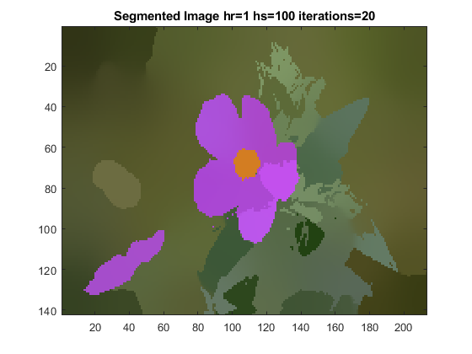
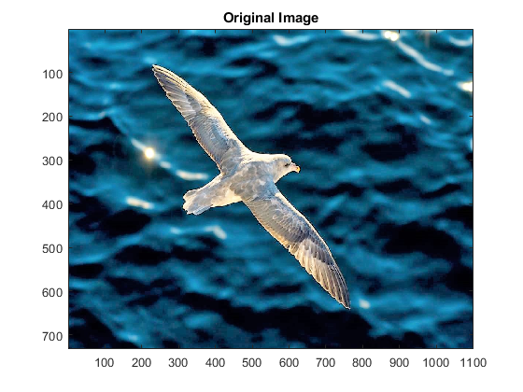
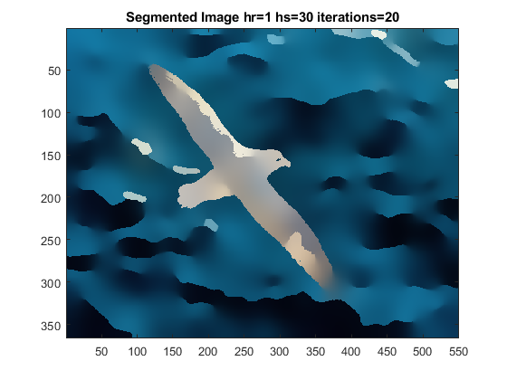
Published with MATLAB® R2020a

